

I can’t wait for you to join us for the Annual Community Yard Sale here in ________________. If you have any questions, please get in touch! Happy selling!   
YOUR NAME HERE

SIGN UP DETAILS

DEADLINE:   
COORDINATOR CONTACT:

Please provide your—NAME, ADDRESS, AND PHONE NUMBER. I must have this information in order to add your residence to the city permit to successfully participate in the community yard sale.

You may email, call, or text your information to me! Also, please mention your top selling items for your yard sale.

PHONE:

EMAIL:

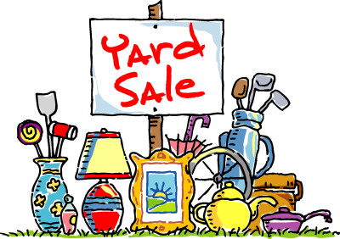

TO PARTICIPATE

On the day of the event, set up your own items in your garage or   
driveway. I’ll do everything else: online advertising, obtaining the city permit, providing signs, and placing signs next to the main roads the day of.

No cost to you! Yay!

DATE:   
TIME:

Insert your neighborhood name here

ANNUAL COMMUNITY YARD SALE

TO PARTICIPATE

On the day of the event, set up your own items in your garage or   
driveway. I’ll do everything else: online advertising, obtaining the city   
permit, providing signs, and placing signs next to the main roads the day of.

No cost to you! Yay!